Lab: Business Rules SOLUTION

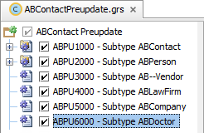

Rule name: ABPU6000 – Subtype ABDoctor

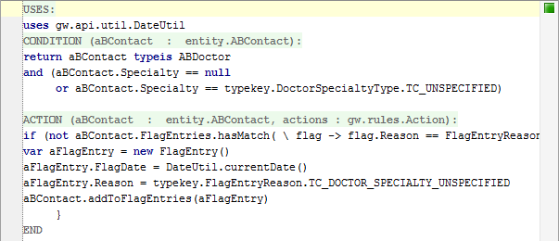

USES:  
uses gw.api.util.DateUtil

CONDITION:  
return aBContact typeis ABDoctor   
and (aBContact.Specialty == null or aBContact.Specialty == typekey.DoctorSpecialtyType.TC_UNSPECIFIED)

ACTION:  
if (not aBContact.FlagEntries.hasMatch( \ flag -> flag.Reason == FlagEntryReason.TC_DOCTOR_SPECIALTY_UNSPECIFIED and flag.IsOpen)) {  
 var aFlagEntry = new FlagEntry()  
 aFlagEntry.FlagDate = DateUtil.currentDate()  
 aFlagEntry.Reason = typekey.FlagEntryReason.TC_DOCTOR_SPECIALTY_UNSPECIFIED  
 aBContact.addToFlagEntries(aFlagEntry)  
}